**Setup Prometheus Binaries**

**Step 1:** Update the yum package repositories.

sudo yum update -y

**Step 2:** Go to official Prometheus [downloads page](https://prometheus.io/download/) and get the download link for Linux binary.

[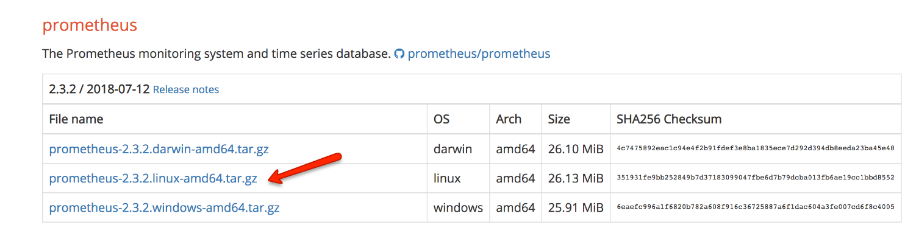](https://devopscube.com/wp-content/uploads/2018/08/prometheus-linux-download-link.png)

**Step 3:** Create a Prometheus user, required directories, and make prometheus user as the owner of those directories.

sudo useradd --no-create-home --shell /bin/false prometheus

sudo mkdir /etc/prometheus

sudo mkdir /var/lib/prometheus

sudo chown prometheus:prometheus /etc/prometheus

sudo chown prometheus:prometheus /var/lib/prometheus

**Step 4:** Download the source using curl, untar it and rename the extracted folder to prometheus-files.

curl -LO https://github.com/prometheus/prometheus/releases/download/v2.3.2/prometheus-2.3.2.linux-amd64.tar.gz

tar -xvf prometheus-2.3.2.linux-amd64.tar.gz

mv prometheus-2.3.2.linux-amd64 prometheus-files

**Step 5:**Copy prometheus and promtool binary from prometheus-files folder to /usr/local/bin and change the ownership to prometheus user.

sudo cp prometheus-files/prometheus /usr/local/bin/

sudo cp prometheus-files/promtool /usr/local/bin/

sudo chown prometheus:prometheus /usr/local/bin/prometheus

sudo chown prometheus:prometheus /usr/local/bin/promtool

**Step 6:** Move the consoles and console_libraries directories from prometheus-files to /etc/prometheus folder and change the ownership to prometheus user.

sudo cp -r prometheus-files/consoles /etc/prometheus

sudo cp -r prometheus-files/console_libraries /etc/prometheus

sudo chown -R prometheus:prometheus /etc/prometheus/consoles

sudo chown -R prometheus:prometheus /etc/prometheus/console_libraries

**Setup Prometheus Configuration**

All the prometheus configurations should be present in /etc/prometheus/prometheus.yml file.

**Step 1:** Create the prometheus.yml file.

sudo vi /etc/prometheus/prometheus.yml

**Step 2:** Copy the following contents to the prometheus.yml file.

global:

  scrape_interval: 10s

scrape_configs:

  - job_name: 'prometheus'

    scrape_interval: 5s

    static_configs:

      - targets: ['localhost:9090']

**Step 3:** Change the ownership of the file to prometheus user.

sudo chown prometheus:prometheus /etc/prometheus/prometheus.yml

**Setup Prometheus Service File**

**Step 1:** Create a prometheus service file.

sudo vi /etc/systemd/system/prometheus.service

**Step 2:** Copy the following content to the file.

[Unit]

Description=Prometheus

Wants=network-online.target

After=network-online.target

[Service]

User=prometheus

Group=prometheus

Type=simple

ExecStart=/usr/local/bin/prometheus \

    --config.file /etc/prometheus/prometheus.yml \

    --storage.tsdb.path /var/lib/prometheus/ \

    --web.console.templates=/etc/prometheus/consoles \

    --web.console.libraries=/etc/prometheus/console_libraries

[Install]

WantedBy=multi-user.target

**Step 3:** Reload the systemd service to register the prometheus service and start the prometheus service.

sudo systemctl daemon-reload

sudo systemctl start prometheus

Check the prometheus service status using the following command.

sudo systemctl status prometheus

The status should show the active state as shown below.

[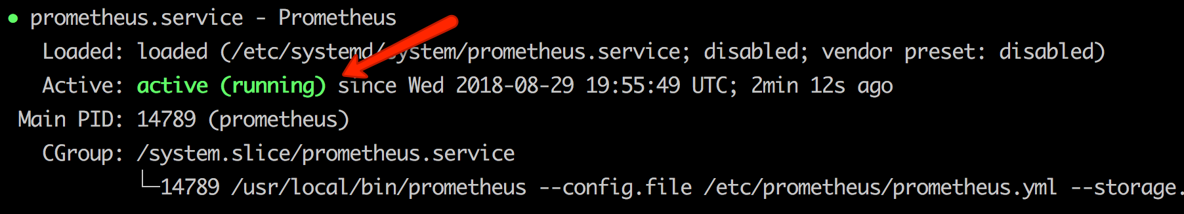](https://devopscube.com/wp-content/uploads/2018/08/prometheus-status.png)

**Access Prometheus Web UI**

Now you will be able to access the prometheus UI on 9090 port of the prometheus server.

http://<prometheus-ip>:9090/graph

You should be able to see the following UI as shown below.

[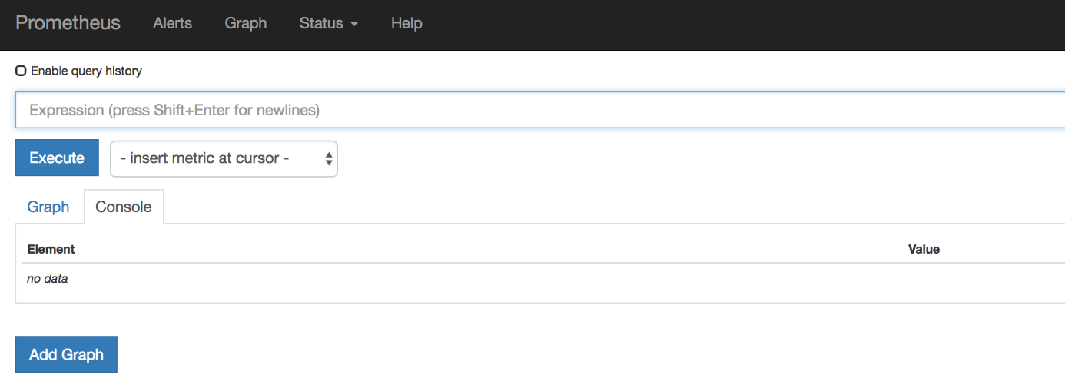](https://devopscube.com/wp-content/uploads/2018/08/prometheus-UI.png)

Right now we have just configured prometheus. You need to register the target in the prometheus.yml file to get the metrics from the source systems.

Follow [Prometheus Node Exporter Guide](https://devopscube.com/monitor-linux-servers-prometheus-node-exporter/) to setup node exporter and registering it to Prometheus server.